Due Diligence Automation System
User Manual

Version 1.0
Draft – 23-February-2017

Developed by:
Clarity Information Technologies Pvt. Ltd.
Bangalore.
Tele: 080 - 2529 1698
Email: mail@claritytechnologies.com

Table of Contents
Introduction 2
PRISM User Administration 2
PRISM Change Management 2
Login 2
Forgot Password 2
Change Password 2
Home 2
Study 2
Validation Error messages 2
Date Picker 2
Context Help 2
User Access Rights 2
Details by Form: 2
Review 2
Description 2
Resources 2
Timelines 2
Status/Pages Flow 2
Data Cleaning Progress 2
Dash Board 2
FTEs 2
Tasks 2
Deliverables 2
CDMS 2
CDMS Tracker 2
CDS 2
CDS Development Request 2
CDS Output Request 2
CDS Delivery Request 2
KPIs 2
QR 2
LL 2
Offline Check 2
Reports 2
Studies 2
Summary 2
Study Details 2
Timelines 2
Deliverables 2
EDC Experience By Study Phase 2
EDC Study Status By System 2
Risks 2
Tasks At Risks 2
Tasks Flagged As Alerts 2
RiskScore 2
Tasks At Risk 2
RiskScore History (List All Reviews) 2
RiskScore History (Graphical BarChart) 2
Resources: 2
Assignments 2
FTE DashBoard 2
Compilance 2
Project Review Compilance 2
Missing forms and Pending Offline Checks 2
Missing Forms 2
Offline Mandatory Checks 2
CDS 2
CDS Development Tasks 2
CDS Output Tasks 2
CDS Delivery Task 2
CDMS 2
CDMS Tasks(List) 2
CDMS tasks(By Task Group) 2
Export Data 2
Admin Functionality 2
PRISM User Administration 2
PRISM Change Management 2
Users 2
Add / Edit: 2
Code List 2
Error Log 2
Mail Log 2
Annoncements 2
Login Details 2
FTE Uploads 2
Generate FTEs 2
Tasks 2
Tasks Group 2
CDMS & CDMS Type 2
Help 2
Alerts 2
Access Security (Login Details form in PRISM) 2
Troubleshooting Guide 2
Common problems: 2
Login Details 2
Personal Settings 2
Logout 2

Introduction

DDAS is Web Application and can be accessed through: http: …. On your web browser.
The main goal of the DDAS application is to aid the user to collate Investigator and Institute related Complaince Issues into Investigator Compliance Search Forms (ICSF).
The application collects Investigator Compliance related data from various pubic sources. The application downloads this every 24 hours and converts it into data repositories.
The application user inputs details such as Project Number, Name of Institute, Country, List of Investigators and their Role, Prinicpal or Sub. The application scans through the latest version of the data repositories for suitable match of Invesigator Name and presents the results to the user for recording observations.
The data is extracted from the following web sites.

Login

Navigate to DDAS via http://ddas.claritytechnologies.com/ in your internet browser. Username and Password are mandatory fields for logging in.

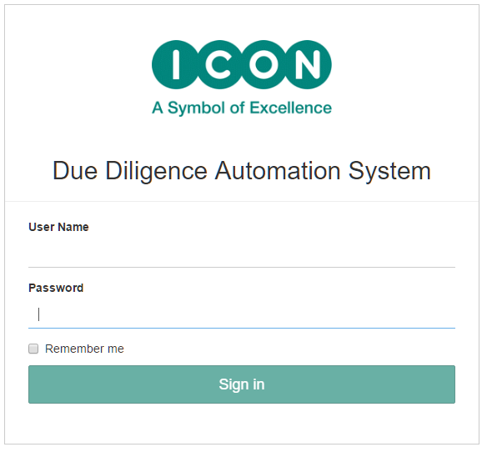

Forgot Password

Not implemented:
Forgotten passwords can be recovered using the ‘Forgot Password’ link on the login page.
Enter your username and e-mail address and click on ‘Re-Generate Password’ as shown below.
An e-mail will be sent to the user’s e-mail address with the re-generated password.
In the event that the ‘Re-generate password’ link is not working please e-mail the DDAS Administrator mailbox: xxxxxxxx for assistance.
The re-generated password can be changed using the ‘Change Password’ link (see next section).

Change Password
The Change password link is accessible via the user menu on the top right-hand side of the screen.

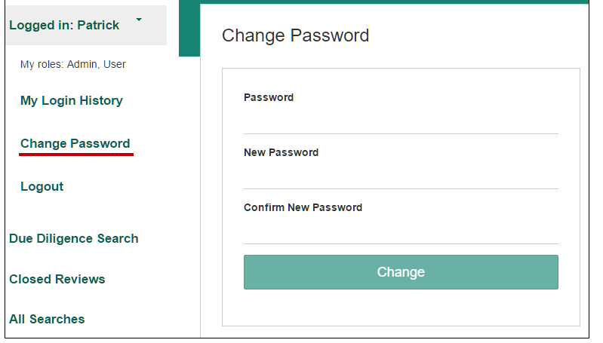

Click ‘Change Password’ to display this screen:

Complete all fields and click update to change the password.

Due Diligence Search

The Due Diligence Search page will be visible to the user immediately after login.

- Carry out Manual Search, Create a Compliance Form,
- Batch Upload an excel file containing multiple data for Compliance Forms
- Download a Compliance Form Template
- Open a Compliance Form for Review.

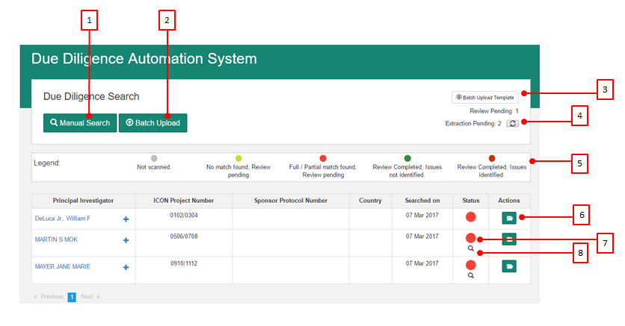

- Manual Search
- Batch Upload
- Batch Upload Template
- Extraction Pending -
- Legend
- Open Compliance Form for edit
- Status of Compliance Form
- Extraction Pending

Compliance Form

The information in the Compliance form is arranged in 7 tabs.

- General Info
- Investigators
- Mandatory Sites
- Additional Sites
- Findings
- Searched By
- Summary
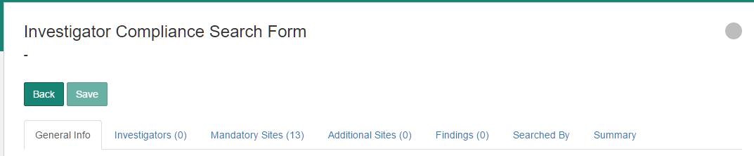

Click on the Save button to save the Compliance Form. A search of all DB sites is carried out automatically for entries matching Investigator Name.

General Info

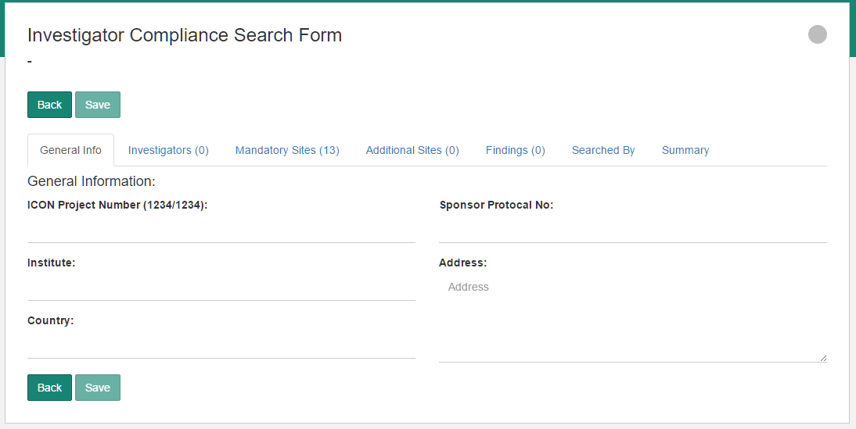

The fields are:
ICON Project Number
Format: dddd-dddd example: 1234-5678
The first 4 digits of the Project Number represent the sponsor.
Institute:
Address
Country

Institute

The Institute tab displays the Institute Name and the list of Site Sources where Search Applies to Institute.

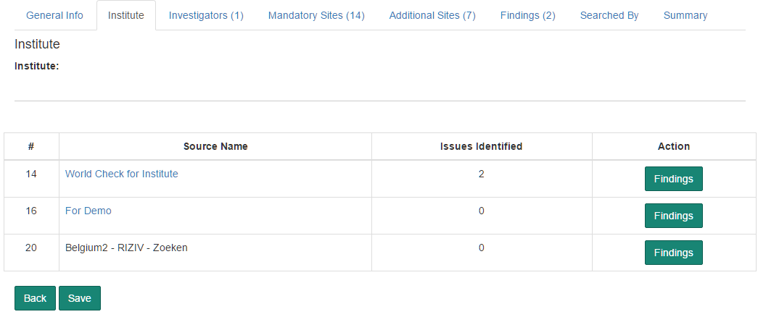

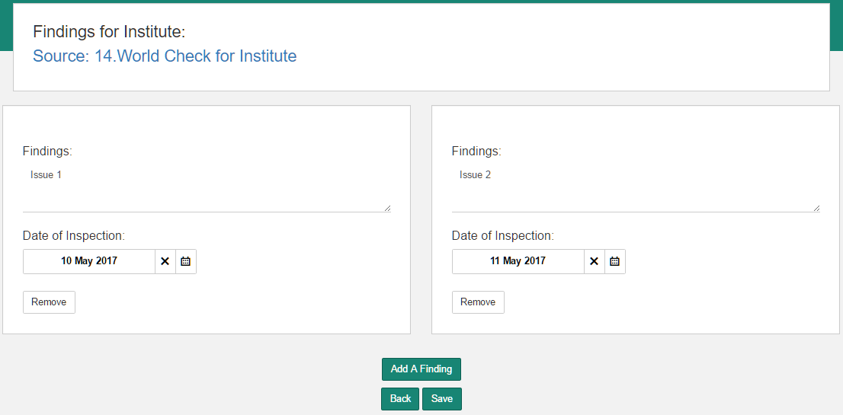

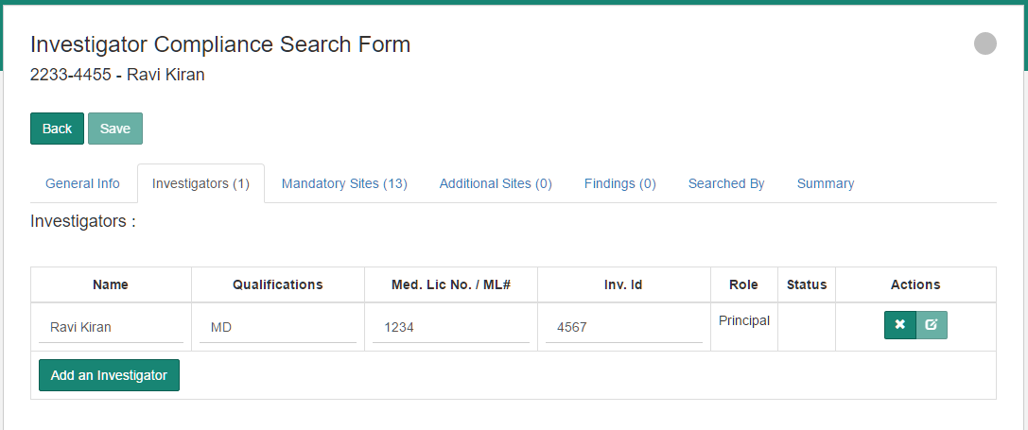

Mandatory Sites

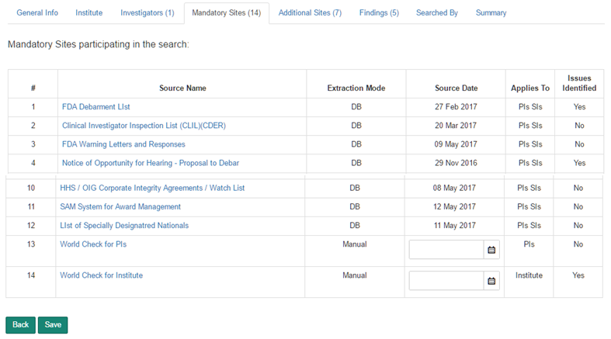

Additional Sites

Note:
Applies to Mandatory and Additional Site:
Source Date is automatically generated for sites applicable to PIs and Sis and whose extraction mode is ‘DB’ . For other sites, the Source Date is recorded by the user.

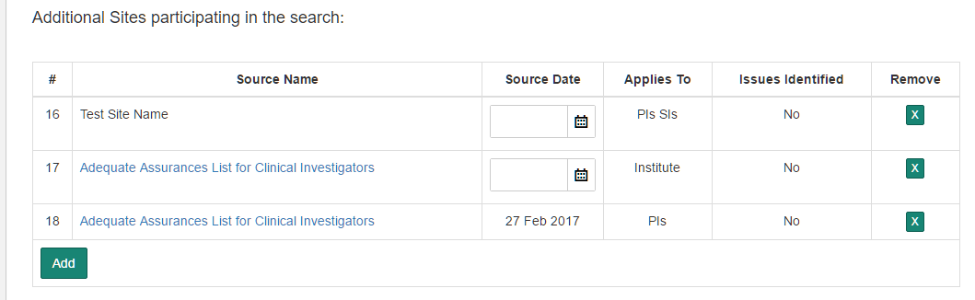

Findings

The findings are listed in the following order:
- Institute in ascending order,
- And then by Source # in ascending order,
- And Then by Date of Inspection in descending order
- And then by Investigator in the same order as the record appears on the Compliance Form,
- And then by Source # in ascending order
- And then by Date of Inspection in descending order.

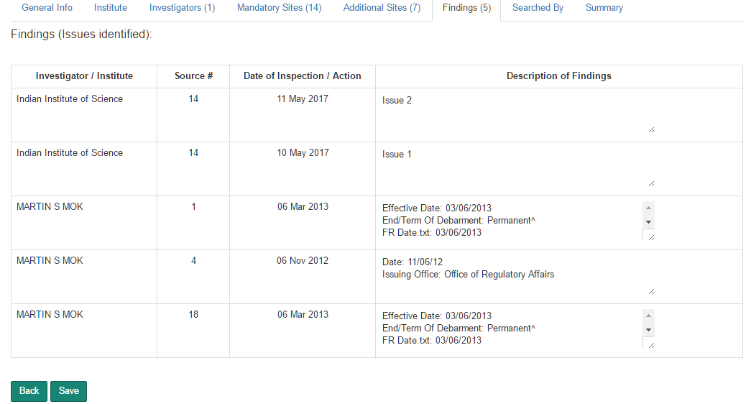

Searched By

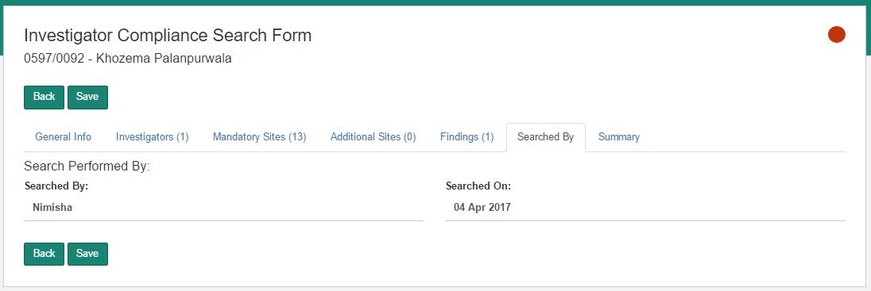

Summary

Page not ready.

Configurations

Site Sources

The Site Sources section displays all the sites available for use with Compliance Forms. The list contains 12 pre-defined Site Sources. The extraction mode for these sites is ‘DB’. These records cannot be removed or modified.
Additional sites can be added to the Site Source list. The extraction mode for additional sites is automatically marked as ‘Manual’
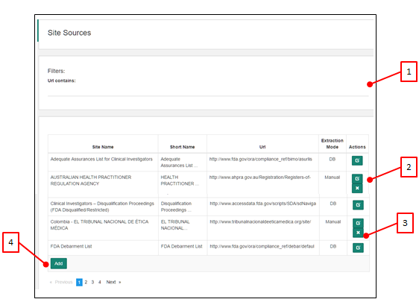
- Filters: Url contains. Filters records matching the text in the Url contains text box.
- Edit Record. Applies to Manual sites. DB Sites cannot be edited.
- Remove Record. Applies to Manual sites. DB Sites cannot be removed.
- Add a new Site Source with the following values:
  - Site Name
  - Short Name
  - URL
  - Extraction Mode: Manual

Default Sites

The application maintains a list Default Sites. The Site Sources listed under this section are added to the compliance form when the form is created.
The fields in the Default Site are:
- Site Url: Selected from the list of Site Sources. Site Sources are managed in the Site Source section.
- Order No: Defines the order in which the Site Sources have to appear in the Compliance Form.
- Name: By default, the Site Name provided by the Site Source is applied. This can be modified.
- Search Applies To options are:
  - PI SI
  - PI
  - Institute
- Mandatory, Yes / No. Mandatory Site Sources are listed under the Mandatory section of the Compliance Form. Not Mandatory Site Sources are listed in the ‘Additional Sites to Search’ section of the Compliance form.
- Extraction Mode: not editable. The Extraction Mode defined in the Site Source section is applied except in the case where the Search Applies To is Insititute. The Default Site Extraction Mode is marked as ‘Manual’ for all records that have ‘Additional Sites To Search’ as Institute.

Country Specific Site Sources

When a Compliance Form is created, the application will add applicable additional Site Sources as defined in this section.
The application matches the value in the Country field of Compliance Form inputs to the list of corresponding sites in the Country Specific Sites List and adds these sites to the Compliance Form.
Note: This functionality is available only when the Compliance Form is created through the Batch Upload mode.

Sponsor Specific Site Sources

When a Compliance Form is created, the application will add applicable additional Site Sources related to a Sponsor.
The application matches the first four digits in the Project Number field of Compliance Form inputs to the list of corresponding sites in the Sponsor Specific Site Sources and adds these sites to the Compliance Form.
Note: This functionality is available only when the Compliance Form is created through the Batch Upload mode.

Test Foot Note

